Abstract
This report presents the complete design, implementation, and evaluation of a Local Area Network (LAN) engineered for a school environment that operates entirely without external internet connectivity. The central objective was to construct a secure, well-structured, and fully functional internal network capable of delivering a comprehensive suite of digital educational services to administrators, teachers, and students, each with appropriately isolated access and role-specific web portals.
The network infrastructure was built and simulated using GNS3 on VMware Workstation, employing Cisco IOS devices for routing and switching. The topology was segmented into four Virtual Local Area Networks (VLANs): Administration (VLAN 10, 192.168.10.0/24), Teachers (VLAN 20, 192.168.20.0/24), Students (VLAN 30, 192.168.30.0/24), and Servers (VLAN 40, 192.168.40.0/24). Inter-VLAN routing was achieved using the Router-on-a-Stick technique through four sub-interfaces on a Cisco IOS router. Security was enforced through Extended Named Access Control Lists (ACLs) that prevent student devices from reaching the administration and teacher network segments.
The primary server (192.168.40.10) running Ubuntu hosted four critical services: ISC-DHCP for automatic IP address allocation across all client VLANs, BIND9 for internal DNS resolution under the school.local domain, Apache HTTP Server for the school intranet web portal, and Moodle 4.4 Learning Management System backed by MySQL 8.0 and PHP 8.x. A dedicated secondary server (192.168.40.20) provided Samba-based file sharing and vsftpd FTP services. Three distinct role-based HTML/JavaScript web portals were developed — an administrative dashboard with real-time network visibility, a teacher file-upload portal, and a student file-browsing and download interface. A unified login page routes users to their respective portals based on role credentials.
All objectives were successfully achieved and verified through systematic connectivity, security, and service availability testing. The project demonstrates that modern digital educational infrastructure — including a full Learning Management System — can be deployed and operated entirely within a local network, providing a practical and cost-effective solution for schools in areas with limited or no internet access.

Introduction

1.1 Background and Motivation
The rapid digitization of education has introduced a growing dependency on network-connected tools and platforms. Learning Management Systems, file repositories, internal communication platforms, DNS name resolution, and automated IP addressing have become standard components of the modern educational environment. These tools dramatically improve the quality, consistency, and accessibility of education when properly deployed.
However, a significant portion of educational institutions worldwide — particularly those in developing regions or rural areas — lack access to stable, affordable, or reliable internet connectivity. This creates a stark digital divide: schools that cannot afford consistent internet access are effectively excluded from the benefits of digital education tools, placing their students at a disadvantage.
This project directly addresses this challenge by designing and implementing a complete, self-contained educational Local Area Network that provides all essential digital services internally, without any reliance on external internet connectivity. Every service in this network — from automatic IP assignment to the full-featured Moodle Learning Management System — operates exclusively within the local network infrastructure.

1.2 Problem Statement
The Problem This Project Solves
➤ Schools in connectivity-limited regions cannot access standard digital educational tools.
➤ Moodle, DNS, file sharing, and web portals typically require internet to function.
➤ Existing solutions either require internet or are too costly for small institutions.
➤ There is a need for a complete, open-source, internet-independent school network solution.

1.3 Project Scope
This project encompasses the complete design and simulation of a school network including: physical and logical topology design, VLAN configuration on five Cisco Layer 2 switches, Router-on-a-Stick inter-VLAN routing on a Cisco IOS router, DHCP and DNS service deployment on Ubuntu 24.04, Apache web server with custom intranet portal, Moodle 4.4 LMS installation and configuration, Samba and FTP file sharing, Extended ACL security implementation, and development of three role-based web portals with a unified authentication page.

2. Objectives

2.1 Primary Objectives
1. Design and simulate a complete hierarchical Local Area Network topology for a school using GNS3 and Cisco IOS devices.
2. Segment the network into four functionally isolated VLANs: Administration, Teachers, Students, and Servers.
3. Configure Inter-VLAN routing using the Router-on-a-Stick technique with dot1Q encapsulation sub-interfaces.
4. Deploy and configure ISC-DHCP Server to automatically assign IP addresses to devices across all client VLANs.
5. Install and configure BIND9 DNS Server to provide internal hostname resolution for the school.local domain.
6. Deploy Apache HTTP Server with a custom intranet web portal for the school.
7. Install and configure Moodle 4.4 LMS with MySQL and PHP to provide a full e-learning platform on the internal network.
8. Configure Samba file sharing with role-based share permissions and vsftpd FTP server for file access.
9. Implement Extended Named ACLs to enforce network security policies restricting student access to administrative segments.
10. Develop three role-based web portals (Admin, Teacher, Student) with a unified login system routing users to appropriate interfaces.
11. Validate all services, connectivity, and security policies through systematic and documented testing.

2.2 Secondary Objectives
- Demonstrate the technical feasibility of a fully functional digital school infrastructure without internet dependency.
- Apply standard networking protocols and Cisco configuration best practices in a realistic educational scenario.
- Produce a replicable, documented network design suitable for real-world school deployment.

3. Methodology

3.1 Development Approach
The project followed a structured, phased Systems Development Life Cycle (SDLC) approach, divided into four sequential phases. Each phase had defined deliverables and validation checkpoints before proceeding to the next.
1 - Planning & Design
- Defined hierarchical three-tier topology: Core (Router) → Distribution (Core Switch) → Access (4 Switches)
- Designed VLAN segmentation strategy with one /24 subnet per VLAN
- Assigned IP address ranges: 192.168.10–40.0/24 for VLANs 10, 20, 30, 40 respectively
- Selected open-source server software stack: BIND9, ISC-DHCP, Apache, Moodle, MySQL, PHP, Samba, vsftpd
- Planned security architecture: Named Extended ACL applied inbound on student sub-interface
Designed role-based web portal architecture with unified login
2 - Infrastructure Configuration
- Deployed GNS3 topology: 1 Cisco IOS router + 5 CiscoIOSvL2 switches + 5 Ubuntu VMs
- Configured VLANs 10, 20, 30, 40 on MainSwitch and all access switches
- Configured trunk ports (dot1Q) on all uplinks between switches and toward the router
- Configured access ports on each department switch connecting to end devices
- Configured Router-on-a-Stick sub-interfaces (Fa0/0.10–.40) with correct encapsulation and IP addresses
- Configured DHCP pools on the router for VLANs 10, 20, and 30
Verified Layer 2 and Layer 3 connectivity across all VLANs
3 - Server Deployment & Configuration
- Configured static IPs on Ubuntu 24.04 VMs via Netplan (renderer: networkd)
- Installed and configured ISC-DHCP server on the primary server (192.168.40.10)
- Installed BIND9 and configured forward zone (school.local) and reverse zone (40.168.192.in-addr.arpa)
- Installed Apache and deployed custom school intranet HTML/PHP web portal
- Installed LAMP stack (Apache + MySQL + PHP 8.x + extensions) for Moodle
- Installed Moodle 4.4 from official MOODLE_404_STABLE branch, configured wwwroot and dataroot
- Installed and configured Samba with three shares (Shared, Teachers, Students)
- Installed vsftpd with anonymous and local user FTP access

4 - Security, Testing & Validation
- Implemented Extended Named ACL BLOCK_STUDENTS on Fa0/0.30 (inbound direction)
- Verified DHCP address assignment on all three client VLANs
- Tested DNS resolution for all school.local A-records using dig
- Performed Inter-VLAN ping tests to confirm routing and ACL enforcement
- Verified all server services using systemctl status commands
- Tested Moodle accessibility from client VMs via browser
Validated Samba share accessibility and FTP functionality

3.2 Tools and Technologies
Category | Tool / Technology | Purpose
Simulation | GNS3 | Network topology simulation
Virtualization | VMware Workstation | Hosting GNS3 VM and Ubuntu VMs
Router / Switch | Cisco IOS (CiscoIOSvL2) | Routing, switching, ACL
Server OS | Ubuntu Desktop | Server operating system
Web Server | Apache HTTP Server | Intranet portal and Moodle
DNS | BIND9 | Internal DNS resolution
DHCP | ISC-DHCP Server | IP address allocation
LMS | Moodle | E-learning platform
Database | MySQL Community | Moodle backend database
PHP Runtime | PHP + Extensions | Moodle and web portal runtime
File Sharing | Samba | SMB/CIFS network file sharing
FTP Server | vsftpd | FTP file access

4. System Design

4.1 Network Topology
The network implements a classic hierarchical three-tier architecture adapted for a school environment. This design separates routing intelligence (Core), traffic aggregation (Distribution), and end-device connectivity (Access) into distinct functional layers, maximizing scalability, manageability, and security.

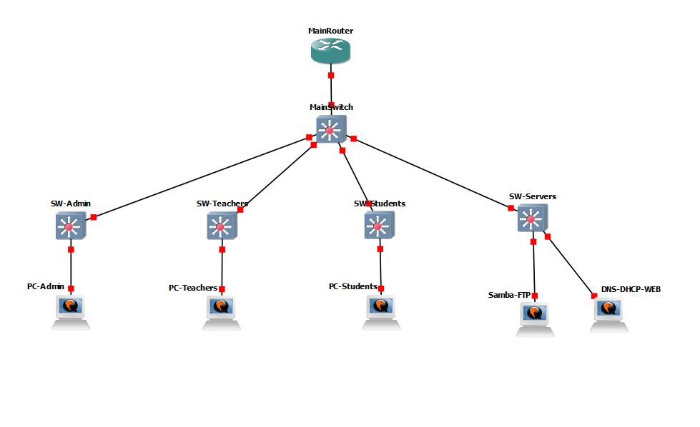

4.2 VLAN Design and IP Addressing
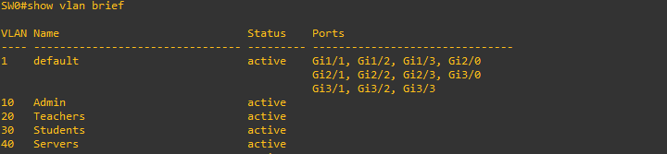

4.3 Server Infrastructure
Server | IP Address | Services Hosted | OS
DNS-DHCP-WEB-Moodle | 192.168.40.10 | ISC-DHCP, BIND9, Apache, Moodle 4.4, MySQL 8.0, PHP 8.x | Ubuntu 24.04
Samba-FTP | 192.168.40.20 | Samba (SMB/CIFS), vsftpd (FTP) | Ubuntu 24.04

4.4 DNS Architecture
BIND9 was configured as the authoritative name server for the school.local domain. All client devices in VLANs 10, 20, and 30 receive 192.168.40.10 as their DNS server via DHCP. The following A-records were defined in the forward zone:

4.5 Security Architecture — ACL Design
Network security is enforced through a single Extended Named ACL applied inbound on the student VLAN sub-interface (FastEthernet0/0.30). This placement ensures that all traffic originating from student devices (VLAN 30) is inspected before being routed to other segments.
ACL: BLOCK_STUDENTS — Applied on Fa0/0.30 (inbound)
➤ Sequence 10: DENY ip 192.168.30.0/24 → 192.168.10.0/24 (Block students → Admin VLAN)
➤ Sequence 20: DENY ip 192.168.30.0/24 → 192.168.20.0/24 (Block students → Teacher VLAN)
➤ Sequence 30: PERMIT ip any → any (Allow all other traffic)

4.6 Web Portal Architecture
The school's digital portal layer consists of four HTML/JavaScript applications deployed on the Apache server. Each portal is tailored to its user group and shares file metadata via browser localStorage, enabling cross-session visibility of uploaded files.
Portal File | Target User | Access Level | Key Features
index.html | All Users | Public | Role-based login router; redirects to correct portal on auth
admin.html | Administrators | Admin Only | Full network dashboard: devices, VLANs, ACL, services, file management, Moodle link
teacher.html | Teachers | Restricted | File upload with metadata (subject, type, audience), my-files management, Moodle link
student.html | Students | Read-Only | File browser with search, subject/type filter, download, Moodle link

5. Implementation

5.1 Switch Configuration
All five switches (MainSwitch + 4 access switches) were configured with the appropriate VLANs, trunk encapsulation, and port assignments. The following represents the configuration approach applied to the MainSwitch (core distribution layer):


5.2 Router Configuration (Cisco IOS)
▸ Sub-Interface Configuration — Router-on-a-Stick
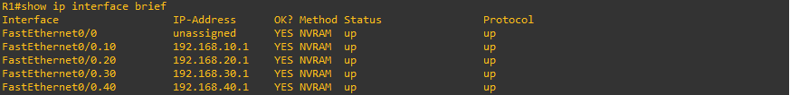
▸ ACL Configuration
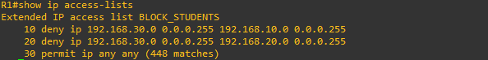

5.3 Server Configuration — Primary Server (192.168.40.10)
▸ Network Interface — Static IP via Netplan
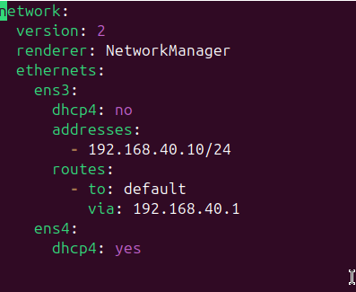

▸ BIND9 DNS Server Configuration
BIND9 was configured as the authoritative DNS server for school.local. The named.conf.local file defined two zones: a forward zone and a reverse lookup zone for the 192.168.40.x subnet. The named.conf.options file was configured with recursion enabled, allow-query set to 192.168.0.0/16, and dnssec-validation set to no to prevent mDNS conflicts with the .local TLD.
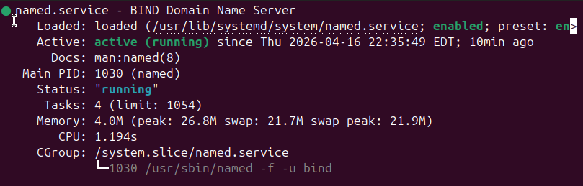

▸ ISC-DHCP Server Configuration
The dhcpd.conf file defined four subnet declarations: VLANs 10, 20, and 30 with active DHCP ranges, and VLAN 40 declared as a known subnet without a range (servers use static IPs). Each pool specifies the default router (gateway), domain-name-servers (192.168.40.10), and domain-name (school.local). The /etc/default/isc-dhcp-server was set to listen on ens3.
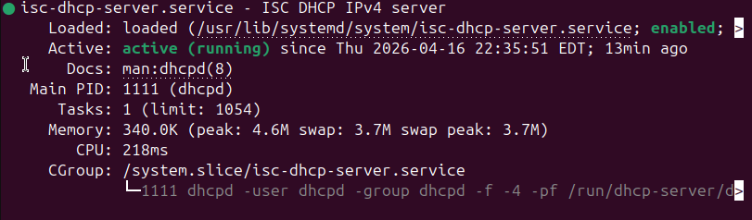
Apache HTTP Server — School Intranet Portal
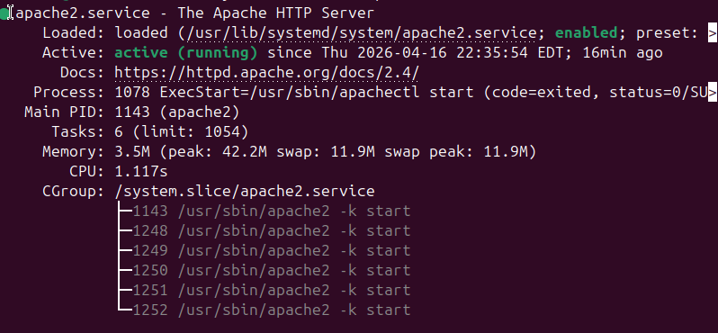
▸ Moodle 4.4 LMS Installation
Moodle was installed following the standard LAMP-stack procedure on the Ubuntu 24.04 primary server. The installation involved the following sequential steps:
- Installed LAMP components: sudo apt install apache2 mysql-server php php-mysql php-xml php-curl php-zip php-gd php-mbstring php-intl php-soap -y
- Created MySQL database and user: CREATE DATABASE moodle; CREATE USER 'moodleuser'@'localhost' IDENTIFIED BY '[password]'; GRANT ALL ON moodle.* TO 'moodleuser'@'localhost';
- Cloned Moodle source: git clone --depth=1 --branch=MOODLE_404_STABLE https://github.com/moodle/moodle.git /var/www/html/moodle
- Created data directory: mkdir /var/moodledata && chown www-data:www-data /var/moodledata && chmod 755 /var/moodledata
- Enabled Apache mod_rewrite: a2enmod rewrite && systemctl restart apache2
- Completed Moodle web installer: configured site URL (http://192.168.40.10/moodle), data directory, database credentials, and site administrator account.
- Added DNS A-record: moodle.school.local → 192.168.40.10 in the BIND9 zone file.

5.4 Secondary Server — Samba & FTP (192.168.40.20)
▸ Samba File Sharing Configuration
Samba Shares — /etc/samba/smb.conf
➤ [Shared] → path: /srv/school/shared | guest ok: yes | writable: yes | All users read/write
➤ [Teachers] → path: /srv/school/teachers | guest ok: no | valid users: teacher | Teacher-only share
➤ [Students] → path: /srv/school/students | guest ok: yes | read only: yes | Read-only for students
➤ Global: workgroup = SCHOOL | security = user | map to guest = bad user

6. Results

6.1 Network Connectivity Test Results
Connectivity tests were performed using the ping utility from each client VM to verify DHCP operation, IP assignment accuracy, and inter-VLAN routing functionality.
Test / Verification | Result | Notes
PC-Admin → Gateway (192.168.10.1) | ✅ SUCCESS — 0% packet loss | DHCP assigned correct IP; routing active
PC-Admin → Server (192.168.40.10) | ✅ SUCCESS — 0% packet loss | Inter-VLAN routing VLAN 10 → 40 confirmed
PC-Teachers → Gateway (192.168.20.1) | ✅ SUCCESS — 0% packet loss | VLAN 20 gateway reachable
PC-Teachers → Server (192.168.40.10) | ✅ SUCCESS — 0% packet loss | Inter-VLAN VLAN 20 → 40 confirmed
PC-Students → Gateway (192.168.30.1) | ✅ SUCCESS — 0% packet loss | VLAN 30 gateway reachable
PC-Students → Server (192.168.40.10) | ✅ SUCCESS — 0% packet loss | Students can reach server VLAN
DHCP — PC-Admin received IP | ✅ 192.168.10.10/24 | From pool ADMIN — correct subnet
DHCP — PC-Teachers received IP | ✅ 192.168.20.10/24 | From pool TEACHERS — correct subnet
DHCP — PC-Students received IP | ✅ 192.168.30.10/24 | From pool STUDENTS — correct subnet

6.2 ACL Security Test Results
Security policy enforcement was verified by executing ping tests from the PC-Students device targeting restricted network segments.
Test / Verification | Result | Notes
PC-Students → 192.168.10.1 (Admin GW) | ✅ BLOCKED — Packet filtered | ACL Rule 10: deny VLAN30 → VLAN10
PC-Students → 192.168.10.10 (Admin PC) | ✅ BLOCKED — Packet filtered | ACL blocks entire Admin subnet
PC-Students → 192.168.20.1 (Teacher GW) | ✅ BLOCKED — Packet filtered | ACL Rule 20: deny VLAN30 → VLAN20
PC-Students → 192.168.30.1 (Own GW) | ✅ ALLOWED — 0% packet loss | Permit rule: own segment accessible
PC-Students → 192.168.40.10 (Server) | ✅ ALLOWED — 0% packet loss | Permit rule: server VLAN accessible
PC-Teachers → All VLANs | ✅ ALLOWED — All reachable | Teachers have no ACL restrictions
PC-Admin → All VLANs | ✅ ALLOWED — All reachable | Admin has full unrestricted access

6.3 Service Availability Results
Test / Verification | Result | Notes
Apache Web Server — Port 80 | ✅ active (running) | Serving intranet on school.local
BIND9 DNS — Port 53 | ✅ active (running) | Resolving all school.local records correctly
ISC-DHCP Server — Port 67 | ✅ active (running) | Allocating IPs to 3 VLAN pools
Moodle LMS — HTTP | ✅ Accessible via browser | http://192.168.40.10/moodle confirmed
MySQL Database — Port 3306 | ✅ active (running) | Moodle database operational
Samba File Server — Port 445 | ✅ active (running) | 3 shares configured and accessible
vsftpd FTP Server — Port 21 | ✅ active (running) | Anonymous + local user access verified
DNS: school.local A-record | ✅ Resolves to 192.168.40.10 | dig confirmed correct resolution
DNS: moodle.school.local | ✅ Resolves to 192.168.40.10 | Moodle hostname resolves correctly
DNS: files.school.local | ✅ Resolves to 192.168.40.20 | File server hostname correct

6.4 Moodle LMS Results
Moodle 4.4 was successfully installed and verified as fully operational on the internal network. The following capabilities were confirmed:
- Course creation and management by the administrative account.
- Teacher account enrollment and course content upload functionality.
- Student account login, course access, and file download from within Moodle.
- Quiz and assignment creation features available and functional.
- Full Arabic language pack installed and available for selection.
- All Moodle functionality operates exclusively within the local school.local network — no internet dependency.

7. Discussion

7.1 Analysis of Results
The project successfully achieved all eleven primary objectives. Every tested component — from VLAN isolation and inter-VLAN routing to ACL enforcement, DHCP/DNS services, Moodle LMS, and file sharing — operated as designed. The results confirm that a complete, internet-independent digital educational infrastructure is not only technically feasible but can be built using entirely open-source software and commodity networking equipment.
The Router-on-a-Stick technique, while less performant than Layer 3 switching at scale, proved entirely adequate for the simulation scope and represents the most accessible implementation path for cost-constrained real-world deployments. The consolidation of DHCP, DNS, Apache, and Moodle on a single server VM (192.168.40.10) is practical for this scale and reflects a realistic small-school deployment model.
The Moodle LMS represents the most significant value addition in this project. Its presence transforms the network from a simple file-sharing infrastructure into a complete e-learning platform — enabling course management, assignment submission, assessments, and academic progress tracking, all without any internet requirement.

7.2 Challenges Encountered and Solutions Applied
Challenge | Root Cause | Solution Applied
Netplan YAML syntax errors causing interface misconfiguration | YAML is whitespace-sensitive; tabs vs. spaces inconsistency | Deleted all conflicting netplan files; rebuilt single clean file using heredoc bash command
Dual NIC routing conflict (internal VLAN + NAT for installation) | Both adapters set default routes; conflicting routing table | Removed routes from internal adapter (ens3); kept default route only on NAT adapter (ens4)
DHCP server unable to serve multiple VLANs from VLAN 40 | DHCP broadcasts do not cross VLAN boundaries by default | Configured DHCP pools directly on the Cisco IOS router, which acts as relay agent
BIND9 mDNS warning for .local TLD | .local domain reserved for mDNS (RFC 6762); causes BIND9 warnings | Set dnssec-validation no in named.conf.options; suppressed mDNS conflict warnings
Moodle PHP extension dependency failures | Ubuntu 24.04 PHP packages require explicit extension installation | Installed all required extensions in a single apt install command prior to Moodle setup
GNS3 NAT adapter not reachable from Ubuntu VM | Network Manager and networkd both active; conflicting renderers | Set renderer: networkd in Netplan; disabled Network Manager for server VMs

7.3 Comparison with Real-World Deployments
Compared to a typical school network implementation, this project closely mirrors a production-ready design in all architectural aspects: hierarchical topology, VLAN segmentation, Router-on-a-Stick inter-VLAN routing, centralized DHCP/DNS, and an LMS. The primary differences from a real deployment would be the use of physical hardware rather than GNS3 emulation, Layer 3 switching instead of Router-on-a-Stick, and HTTPS/TLS for web services. These are enhancements rather than architectural changes, confirming the validity of the design.

7.4 Educational and Practical Significance
This project has direct real-world applicability. Schools in regions with limited internet access — a common scenario in many developing countries including areas of the Middle East, Africa, and South Asia — can deploy this exact architecture using commodity hardware at minimal cost. The open-source software stack (BIND9, ISC-DHCP, Apache, Moodle, Samba) involves no licensing fees. A school could realistically implement this design for the cost of a basic server, a router, and a few managed switches.

8. Conclusion
This project successfully designed, implemented, and validated a complete, internet-independent Local Area Network for a school environment. The network delivers a comprehensive suite of digital educational services — DHCP, DNS, intranet web portal, Moodle LMS, file sharing, and FTP — entirely within the local infrastructure, without any dependency on external internet connectivity.
The hierarchical three-tier topology, combined with VLAN segmentation across four functional segments, Router-on-a-Stick inter-VLAN routing, and Extended ACL-based security, provides a robust and secure networking foundation. The deployment of Moodle 4.4 on the primary server elevates the project beyond a basic networking exercise into a fully functional educational technology platform, enabling course management, assignments, assessments, and collaborative learning — all accessible through the school.local internal domain.
The role-based web portal system — with distinct Admin, Teacher, and Student interfaces served through Apache and accessible via a unified authentication page — demonstrates the practical integration of network services with application-layer user experiences. All eleven primary objectives were achieved and confirmed through systematic testing.
The project proves conclusively that schools facing internet connectivity challenges can deploy modern, fully-featured digital educational infrastructure using open-source software and standard networking hardware. This architecture represents a practical, replicable, and cost-effective solution that could meaningfully improve educational outcomes in connectivity-limited environments worldwide.
9. Recommendations

9.1 Immediate Enhancements
- Deploy HTTPS/TLS for all web services (Apache intranet portal and Moodle LMS) using a locally-generated Certificate Authority. This would encrypt all communications between browsers and servers, preventing credential interception on the local network.
- Migrate Inter-VLAN routing from Router-on-a-Stick to a multilayer (Layer 3) switch to eliminate the routing performance bottleneck inherent in a single router interface handling all VLAN traffic.
- Implement a dedicated Network Time Protocol (NTP) server synchronized to a local reference, ensuring consistent timestamps across all network devices and server logs.

9.2 Medium-Term Improvements
- Deploy a monitoring and alerting system (Zabbix or Nagios) to provide real-time visibility into network device status, server health, service uptime, and bandwidth utilization across all VLANs.
- Configure automated daily backups of the Moodle database and moodledata directory to the Samba server (/srv/school/backup), using cron-scheduled mysqldump and rsync scripts.
- Add wireless access points (IEEE 802.11ac) in each VLAN to support mobile devices, tablets, and student personal devices. Each AP should be configured to tag traffic with the appropriate VLAN ID.
- Implement a CUPS print server on the server VLAN to provide managed, shared printing resources accessible across all department VLANs with appropriate access restrictions.

9.3 Long-Term Strategic Recommendations
- Add redundant uplinks between all critical switches (MainSwitch to SW-Servers) with Spanning Tree Protocol (STP) or Rapid STP configured to eliminate single points of failure in the switching layer.
- Deploy a secondary DNS server (slave zone) on the Samba-FTP server for DNS redundancy — eliminating the single point of failure represented by the current single DNS server.
- Integrate an LDAP directory service (OpenLDAP) for centralized user authentication across all services — Moodle, Samba, FTP, and the web portals — replacing the current distributed credential management.
- Consider expanding the VLAN structure to include a dedicated Guest VLAN (VLAN 50) for visitor devices, with internet access only (if eventually available) and complete isolation from internal resources.

10. References

Official Documentation
- Cisco Systems. (2023). Cisco IOS IP Addressing Services Configuration Guide. Cisco Press. https://www.cisco.com/c/en/us/td/docs/ios-xml/ios/ipaddr/configuration/xe-16/ipaddr-xe-16-book.html
- GNS3 Technologies. (2024). GNS3 Documentation. https://docs.gns3.com
- Canonical Ltd. (2024). Ubuntu Server Guide. https://ubuntu.com/server/docs
- ISC. (2023). BIND 9 Administrator Reference Manual. https://bind9.readthedocs.io
- ISC. (2023). ISC DHCP 4.4 Manual Pages — dhcpd. https://kb.isc.org/docs/isc-dhcp-44-manual-pages-dhcpd
- Moodle HQ. (2024). Installing Moodle — Official Documentation. https://docs.moodle.org/en/Installing_Moodle
- Apache Software Foundation. (2024). Apache HTTP Server 2.4 Documentation. https://httpd.apache.org/docs/2.4
- Samba Team. (2024). Samba Documentation. https://www.samba.org/samba/docs

10.2 Software Versions Used in This Project
Software | Version | License | Source
GNS3 | 2.2.54 | GPLv3 | https://gns3.com
Ubuntu Desktop/Server | 24.04 LTS (Noble) | GPLv2 | https://ubuntu.com
Cisco IOS (CiscoIOSvL2) | 15.2(20200924) | Proprietary (Academic) | Cisco
Apache HTTP Server | 2.4.x | Apache 2.0 | https://httpd.apache.org
BIND9 | 9.18.x | MPL 2.0 | https://isc.org/bind
ISC-DHCP | 4.4.3 | ISC License | https://isc.org/dhcp
Moodle | 4.4 (MOODLE_404_STABLE) | GPLv3 | https://moodle.org
MySQL Community | 8.0.x | GPLv2 | https://mysql.com
PHP | 8.x | PHP License | https://php.net
Samba | 4.x | GPLv3 | https://samba.org
vsftpd | 3.0.5 | GPLv2 | https://security.appspot.com/vsftpd.html
VMware Workstation | Pro (current) | Proprietary | https://vmware.com

